**Language Fundamentals**

1. Identifiers
2. Reserved keywords
3. Data Types
4. Literals
5. Arrays
6. Types of variables
7. Var arg methods
8. Main method
9. Command line arguments
10. Java coding standards

**Identifiers**

A name in java program is called identifier which can be used for identification purpose. It can be method name or variable name class name or label name

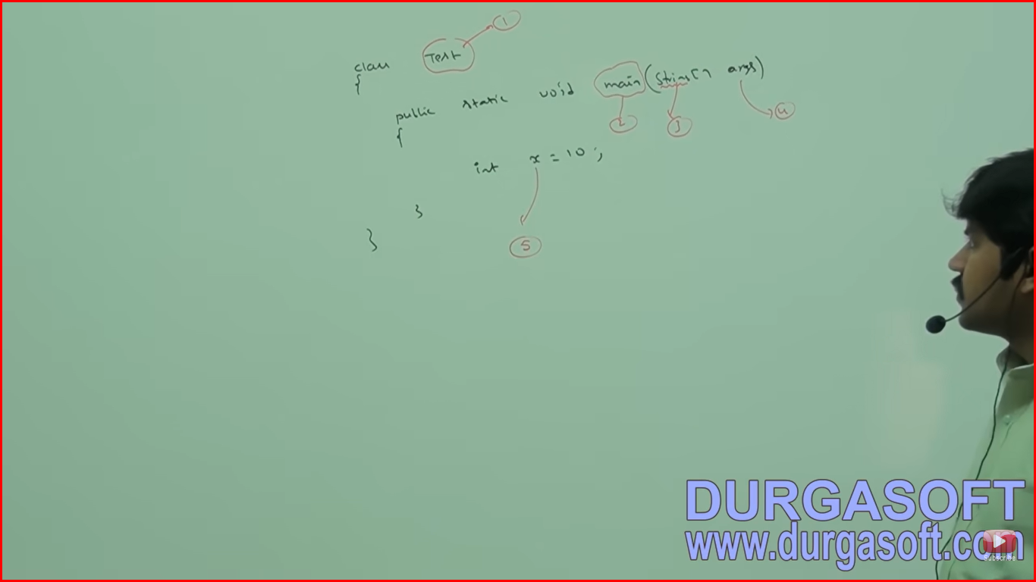

String – It is predefined java class name.

Args – name of array

In Java, a **label** is a name you can assign to a loop or a block of code. It's primarily used with break and continue statements to control the flow of nested loops or switch-case statements more precisely. Labels help you exit or continue specific loops rather than just the innermost one

**Rules for defining Java Identifiers**

**a to z**

**A to Z**

**0 to 9**

**$, _ (dollar and underscore)**

If we are using any other character then we will get compile time error. The only allowed characters in java identifiers are above

Eg: total_number – valid

Total# - invalid

**2. Identifiers can’t start with digits**

For eg: total123 – valid

123total - invalid

**3. Java identifiers are case sensitive. Ofcourse Java language itself is treated as case sensitive programming language**

Class Test{

Int number = 10;

Int Number = 20;

Int NUMBER=30;

}

**4. There is no length limit for identifiers but it is not good programming practice.**

**5. We can’t use reserved word as identifiers.**

For eg int x = 10; - valid

Int if = 20; - invalid

**6. All predefined Java class names and interface names we can use identifiers. Even though it is valid but it is not a good programming practice because it reduces the readability and creates confusion.**

For Eg:

**int String = 888; - valid**

**System.out.println(String);**

**int Runnable = 999; - valid**

**System.out.println(Runnable);**

Here is a complete list of reserved keywords in Java:

1. **Control Flow Keywords:**
   * if
   * else
   * switch
   * case
   * default
   * while
   * do
   * for
   * break
   * continue
   * return
   * try
   * catch
   * finally
   * throw
   * throws
   * assert
2. **Access Modifiers:**
   * private
   * protected
   * public
3. **Class, Interface, and Inheritance Keywords:**
   * class
   * interface
   * extends
   * implements
4. **Object Keywords:**
   * new
   * this
   * super
5. **Exception Handling Keywords:**
   * try
   * catch
   * finally
   * throw
   * throws
6. **Modifiers:**
   * abstract
   * final
   * static
   * transient
   * volatile
   * synchronized
   * native
   * strictfp
7. **Primitive Data Types:**
   * boolean
   * byte
   * char
   * short
   * int
   * long
   * float
   * double
8. **Other Keywords:**
   * void
   * enum
   * instanceof
   * package
   * import
   * throws
   * return
   * const (not used, reserved for future use)
   * goto (not used, reserved for future use)
   * null
   * true
   * false
9. Which of the following are valid java identifers.

total_number - vald

total# - Invalid

123total - Invalid

total123 – Valid

Ca$h –Valid

_$_$_$_$_$ - valid

all@hands - Invalid

Java2share - valid

Integer - valid

Int- valid

int – Invalid

**Reserved Keywords in Java – 53**

**In Java some words are reserved to respresent some meaning or functionality**

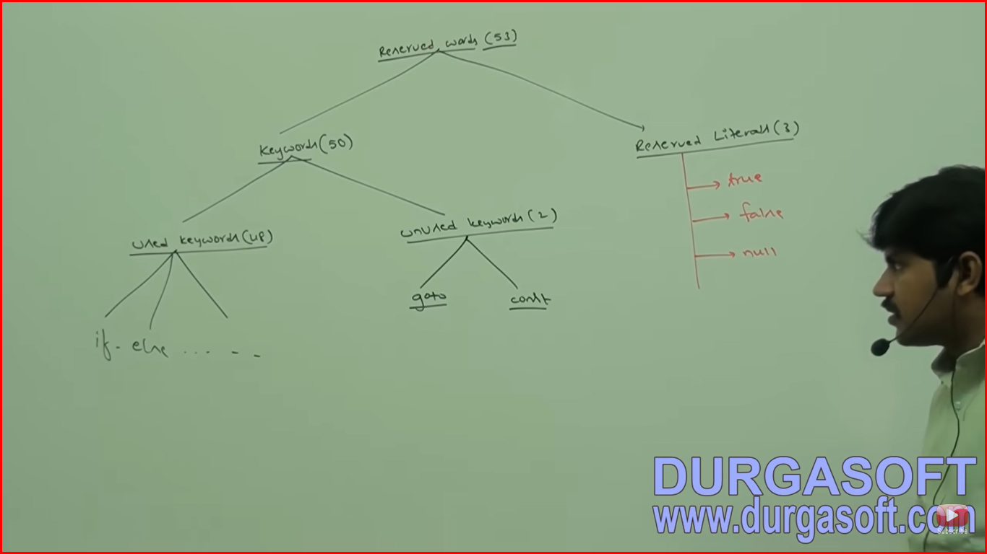

**Keywords for Datatypes**

**byte**

**short**

**int**

**double**

**long**

**float**

**boolean**

**char**

**Keywords for flow control (11)**

if

else

switch

case

default

while

do

for

break

continue

return

**Keywords for modifiers**

public

private

protected

static

final

abstract

synchronized

native

strictfp

transient

volatile

**Keywords for exception handling**

try

catch

finally

throw

throws

assert

**Keywords for class**

class

interface

extends

implements

package

import

**Keywords for object**

new

instanceof

super

this

**void return type keyword**

Return type is optional in C language and default return type is int.

**Unused keywords**

goto – Usage of goto created several problems in old languages and hence sun people banned this keyword in java

const – To define constant but final is already there

The above keyword are unused keywords and if we are trying to use we will get compile time error.

**Reserved Literals**

true

false

nul

The above (true/false) data types of boolean and null is default values for object reference.

**enum Keyword (1.5 version)**

**enum Month{**

**JAN,FEN…DEC**

**}**

The following are new keywords in java:

strictfp(1.2), assert(1.4), enum(1.5)

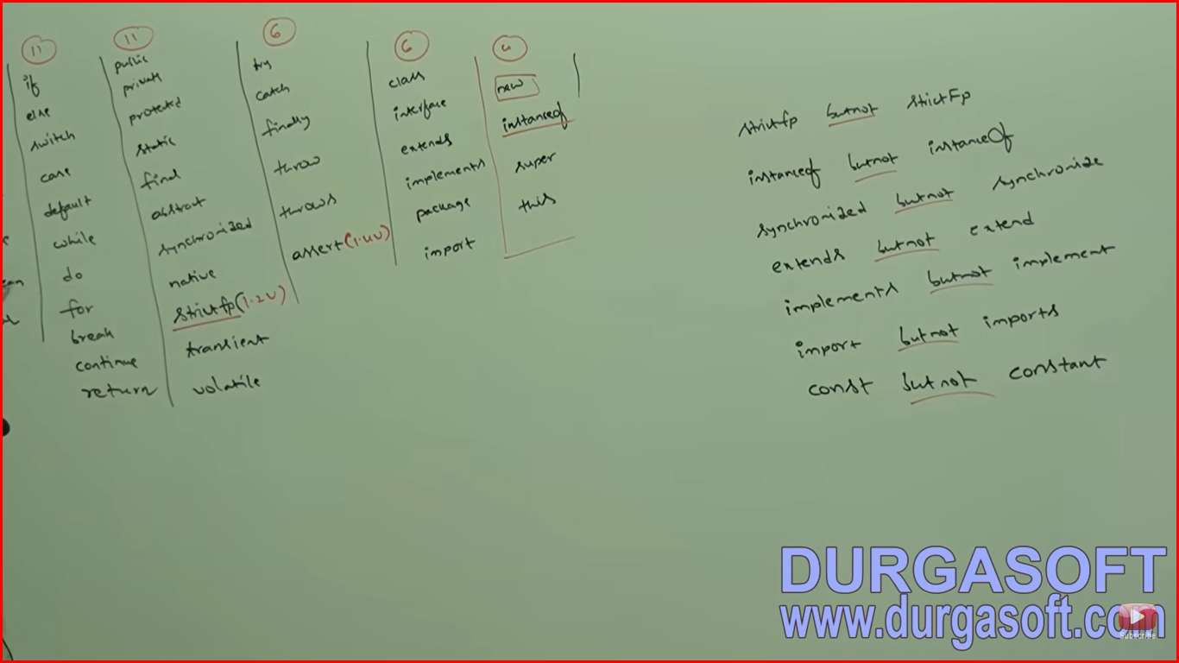

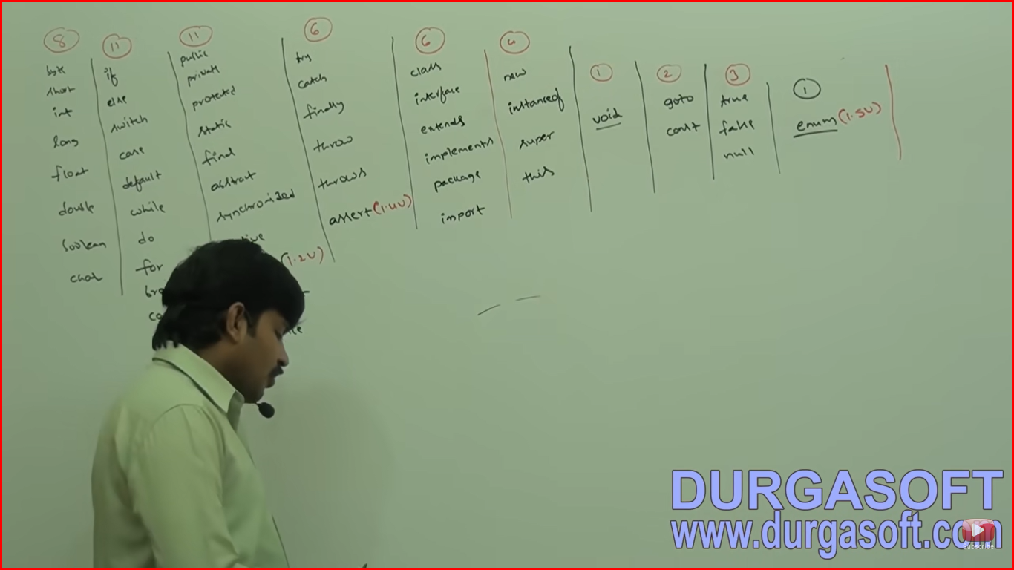

Which of the following list contains only java reserved words?

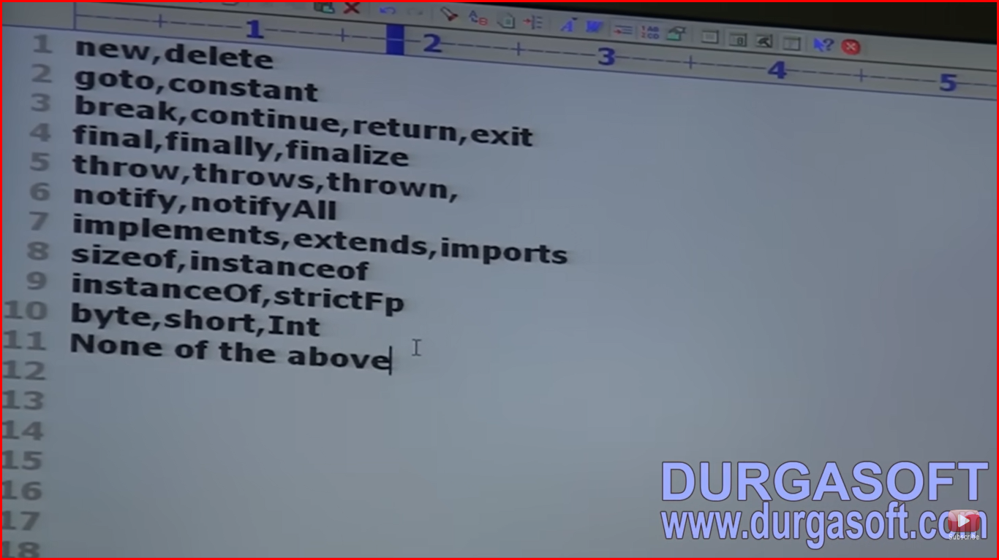

None of the above is correct answer

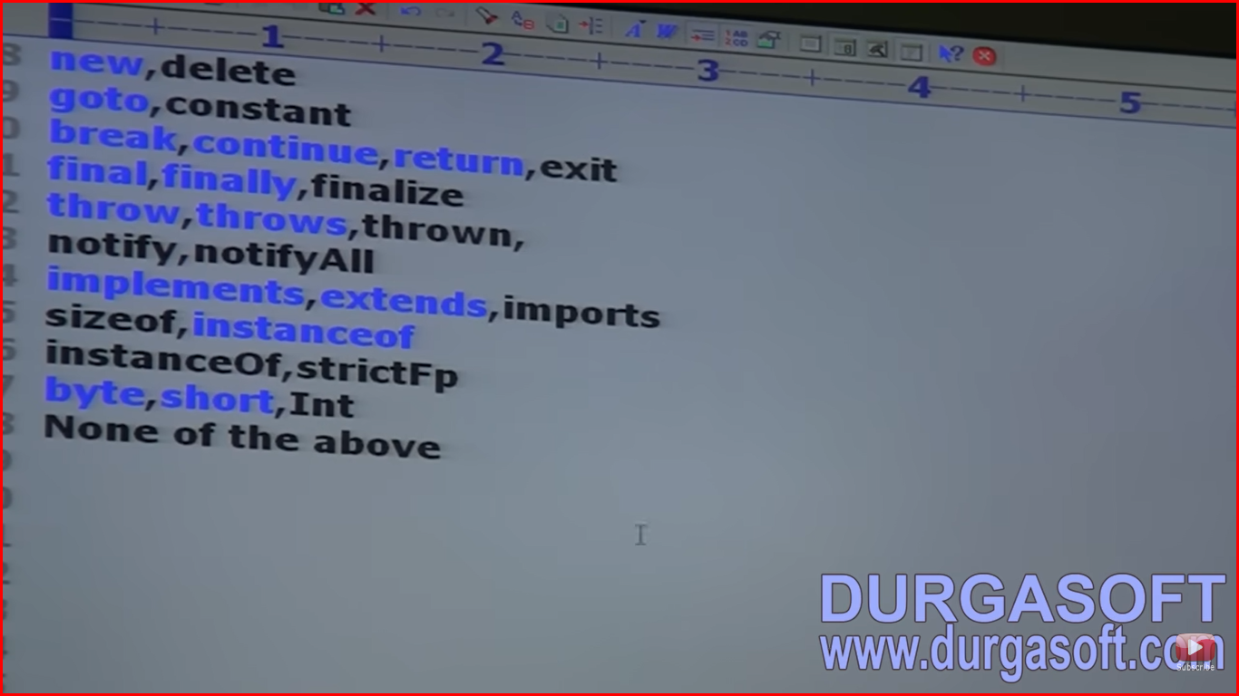

Which of the following are reserved words?

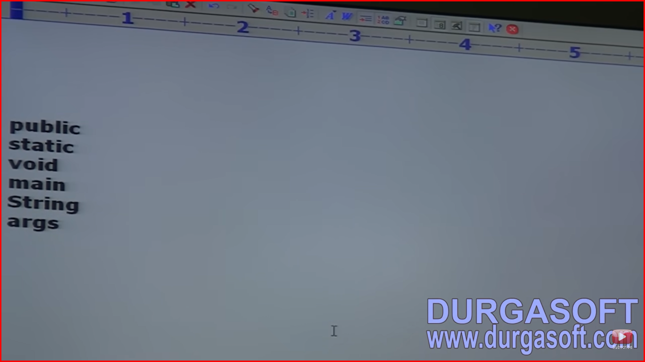

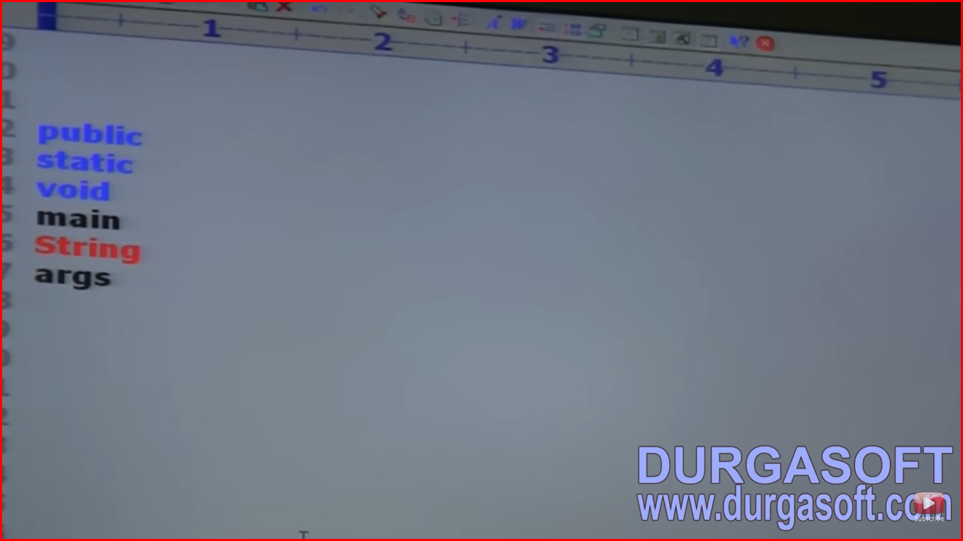

public,static,void – answer